# Emmanuel Klein and Marcela Nowak

# Times of Dylan

## Idea

This is a conceptual piece which aims to show the reverence of Bob Dylan’s work by drawing the viewer back into the moment in time the music was created. The goal is to show both the timeliness and timelessness of his songs.

A long hallway set up with Dylan Lyrics on one side and images/movies from that moment in time on the other wall. As you walk down this long hallway you are physically walking through the timeline. Unidirectional speakers will play the current album.

In order to draw out the almost visual nature of Dylan’s lyrics and to give some visual focus points adjective - noun combinations are highlighted and enlarged in the text on the wall.

## What We Did

* Scrubbed <http://www.azlyrics.com/> to get all of Dylan’s lyrics using Python and BeautifulSoup.
* Processing to display and process the text using RiTa
* Amassed a series of images that where relevant during the time that Dylan was producing and putting out his images
* Created a Unity representation of what this might look and feel like. (<http://itp.marcelanowak.com/data_art/bobDylanWeb/bobDylanWeb.html>)
* Created a THREEJS representation of what this might look and feel like for easy web viewing. (<http://emmanuelklein.com/classes/data%20art/dylan/)>
* Slideshow to display the idea.

## Challenges

* Using python to scrub 400 songs kept locking up my IP address. I tried to add a pause between each quarry but I would still get locked out after about 50 songs and needed to find another IP address. VPNs worked to different degrees of success.
* Dealing with the scale of a large wall while working with small elements (the words).
* Processing had memory issues and creating large format canvases.
* Creating a small representation of a large and detailed that holds true to both scales is challenging.

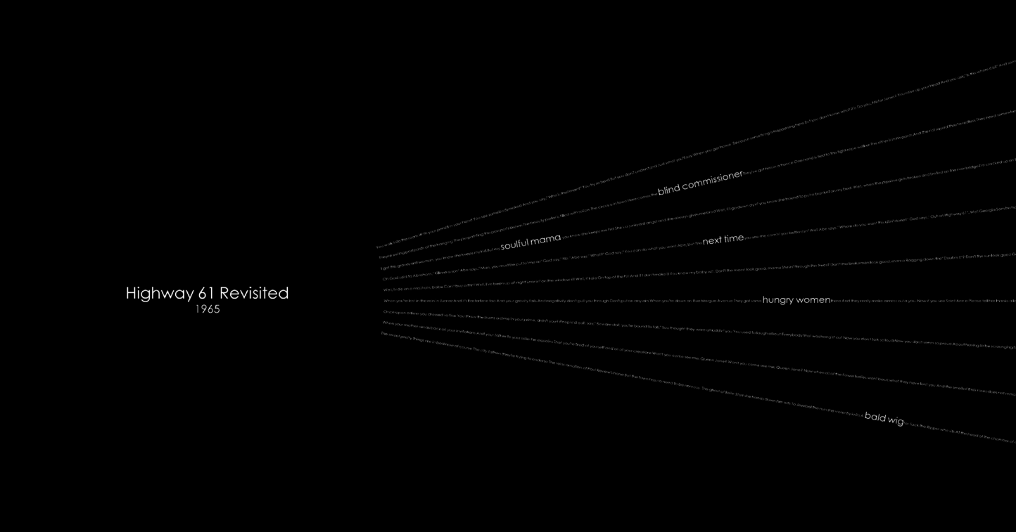

Zoomed in

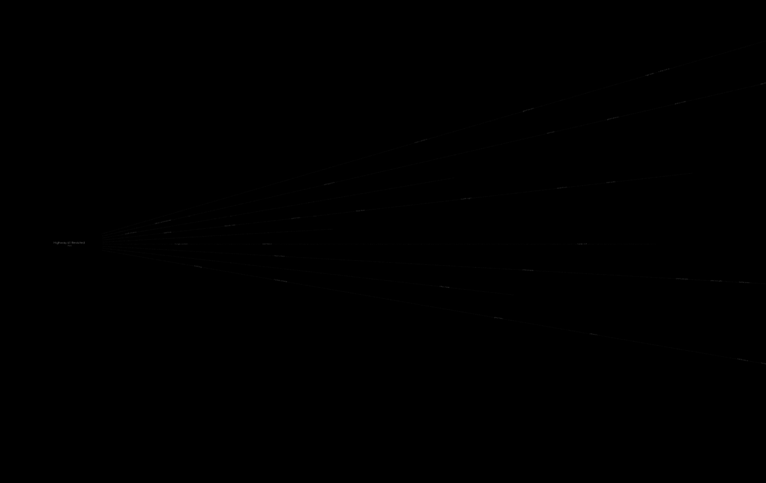

Zoomed out